**Team Lucky Charms**

Catherine Bradsher

Heman Kolla

Christian Marinkovich

Kellie Ng

Billy Wu

Miranda Zheng

**Lab Inventory Management and Borrowing System (LIMBS)**

**Project Proposal**

**Project Summary**

The Lab Inventory Management and Borrowing System (LIMBS) will streamline the tracking, management, and restocking of items within a lab or shop. LIMBS maintains a centralized database that contains real-time access to lab inventory data. The database will allow users to efficiently check out and return reusable equipment, or mark supplies like resistors as used, while keeping an accurate log of all activities. The goal of LIMBS is to enhance accountability for materials and equipment and reduce the burden of manually tracking inventory.

By implementing a user authentication system, LIMBS ensures that only authorized users can manage the inventory. Superusers, who are the creators of the site, will give admin privileges to the appropriate users, such as the professor in charge of a lab or the student leaders of a shop. Administrators can add or remove items from their lab’s/shop’s inventory and monitor what equipment has been checked out when and by whom. If an item is not returned, administrators can see who last had it and when they checked it out, which will help them find it. This should increase accountability for reusable equipment. Administrators can also see if they are running low on supplies.

**User Personas and Stakeholders**

*Professors* - Using an automated system to keep track of equipment means professors don’t have to spend time doing so themselves. This leaves them with more time to spend teaching and helping students, and having fewer things to worry about will let them be more focused while doing so.

*Shop Student Leadership* - Students who run shops will have more free time if they can easily keep track of equipment. Increased accountability for lab equipment means they will have to spend less on replacing lost items, and can get more out of their groups’ budget.

*Lab Students* - Since professors won’t have to worry about tracking equipment as much, students will get more time to ask them questions, and will benefit from professors being more focused on teaching. Forgetful students will also be less likely to accidentally lose or walk away with equipment, as they will have a written record of which items they have checked out.

*RPI Community* - Increasing accountability for lab equipment will decrease the number of lost items, which means less money will be spent on replacements. These freed-up funds could then be dedicated to improving other aspects of the school, which could benefit the whole community.

**Intended Technologies**

We will use HTML, CSS, and JavaScript to build the frontend. For the backend, we intend to use PHP and MySQL, with PHP handling any server-side operations and MySQL maintaining the database. LIMBS will require this database to store each lab or shop’s inventory, whether each item is currently checked out or has been used, and if so by whom. MySQL will also handle user credentials and the authentication process, storing usernames, passwords, and roles (regular user or admin) to ensure only authorized users can use LIMBS. We will also use GitHub Projects to keep track of our work and stay on schedule.

**Functional Requirements**

*Inventory Management and Search*

Users should be able to view a list of all available equipment that is in the lab and anyone with an administrator role (i.e. the professor) will have the ability to add new things to the inventory, update existing entries, and delete any items that are not offered within the lab anymore. The ability to search the inventory will let users quickly find the specific item they need. Users should have the option to search for something based on the item’s name, category, availability, or use.

*User Authentication*

LIMBS will also implement a user authentication system to ensure that access to the system is secure and to allow the system to keep track of the equipment that is checked out. Users will be able to create accounts and log in using their username and password. If there are multiple labs or rooms where the equipment can be accessed, then only the people authorized to access the lab will be able to access the inventory. Users with admin privileges will also be able to access any inventory management features to update the system. They can also see which user checked out items from their lab, so they know who to contact to find missing items. Having this user authentication will ensure that only users with the necessary permissions can check out items or update inventory records.

*Borrowing and Returning System*

The system will allow Users to check out items and return them. To keep track, LIMBS will record the borrower’s information, item information, checkout date, and estimated return date. Once returned, LIMBS should update its inventory to reflect the item’s availability again.

**Nonfunctional Requirements**

*Usability*

The interface of LIMBS should be intuitive and easy to navigate to ensure that users can check out items, view the inventory, and complete any other tasks without too much confusion. An easy interface will also make it easy for newer users and those who might not be as tech-savvy to get used to the platform fast.

*Security*

Since the system manages a lot of data about user accounts, inventory records, and usage histories, making sure there is secure authentication and authorization is essential to protect this data. This will be especially important within labs where the equipment might be very expensive or sensitive.

*Scalability*

As the lab or shop grows, LIMBS will also be able to accommodate the increased demands that this growth might bring. This could be in terms of an increased number of users or the volume of the equipment or inventory being managed. The database will be created to handle larger datasets without slowing down too much to preserve performance.

*Adaptability*

While LIMBS is designed for managing lab equipment, the goal is to have the system be adaptable to other settings as well, maybe like office inventory or campus shops. This flexibility will allow LIMBS to be used in a wide range of environments. It will be designed with modularity in mind, allowing users with admin powers to customize inventory details based on the type of item(s) that are being tracked (ex. serial numbers, size, best-by date for perishables, or maintenance schedules/deadlines for lab equipment).

**Projected Project Schedule**

*September 9th - 23rd*

The first two weeks will consist of just planning and designing the application. We want to reach out to professors and other shops around campus to ask their thoughts on the application and adjust accordingly to refine our functional and non-functional requirements. As a team, we will also work on finalizing a wireframe of LIMBS and designing the structure of MySQL.

*September 24th - October 14th*

Following this, we will begin frontend and backend development, ideally with half the team working on the frontend and another half on the backend. For the frontend, the goal is to set up the structure using HTML, CSS, and Javascript and create static versions of the login, registration, dashboard, and inventory views. The backend team will work on setting up the PHP and MySQL database, implement the database structure, and ensure user registration, login, and item checkout and check-in work.

*October 15th - November 11th*

Once the initial frontend and backend are finished, we will work on connecting the two parts. There must be a smooth connection between the frontend and the backend so that the frontend displays the correct information and any updates are reflected in the backend. On the frontend, this includes making sure that the dynamic inventory view is working and the check-in/checkout system is working. For the backend, this means making sure that admin and user-specific features are implemented, along with the right user role verification logic.

*November 12th - December 2nd*

The final few weeks will consist of testing the application and double-checking all the functionalities of LIMBS works. If there is time, it would be good to get feedback from the professors and other shops who might benefit from using LIMBS.

**Sitemap**



**Wireframes**

The following two wireframes walk through what it might look like if a user is trying to check out the item. Once logged in and the lab is selected, LIMBS will show the inventory available for that specific lab.

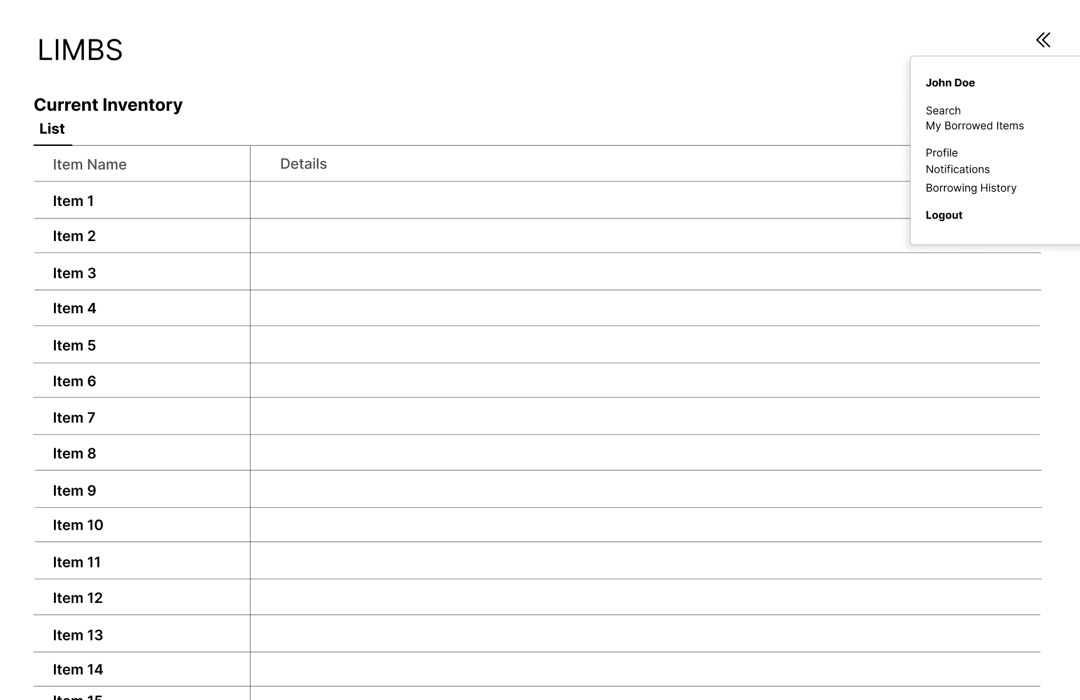

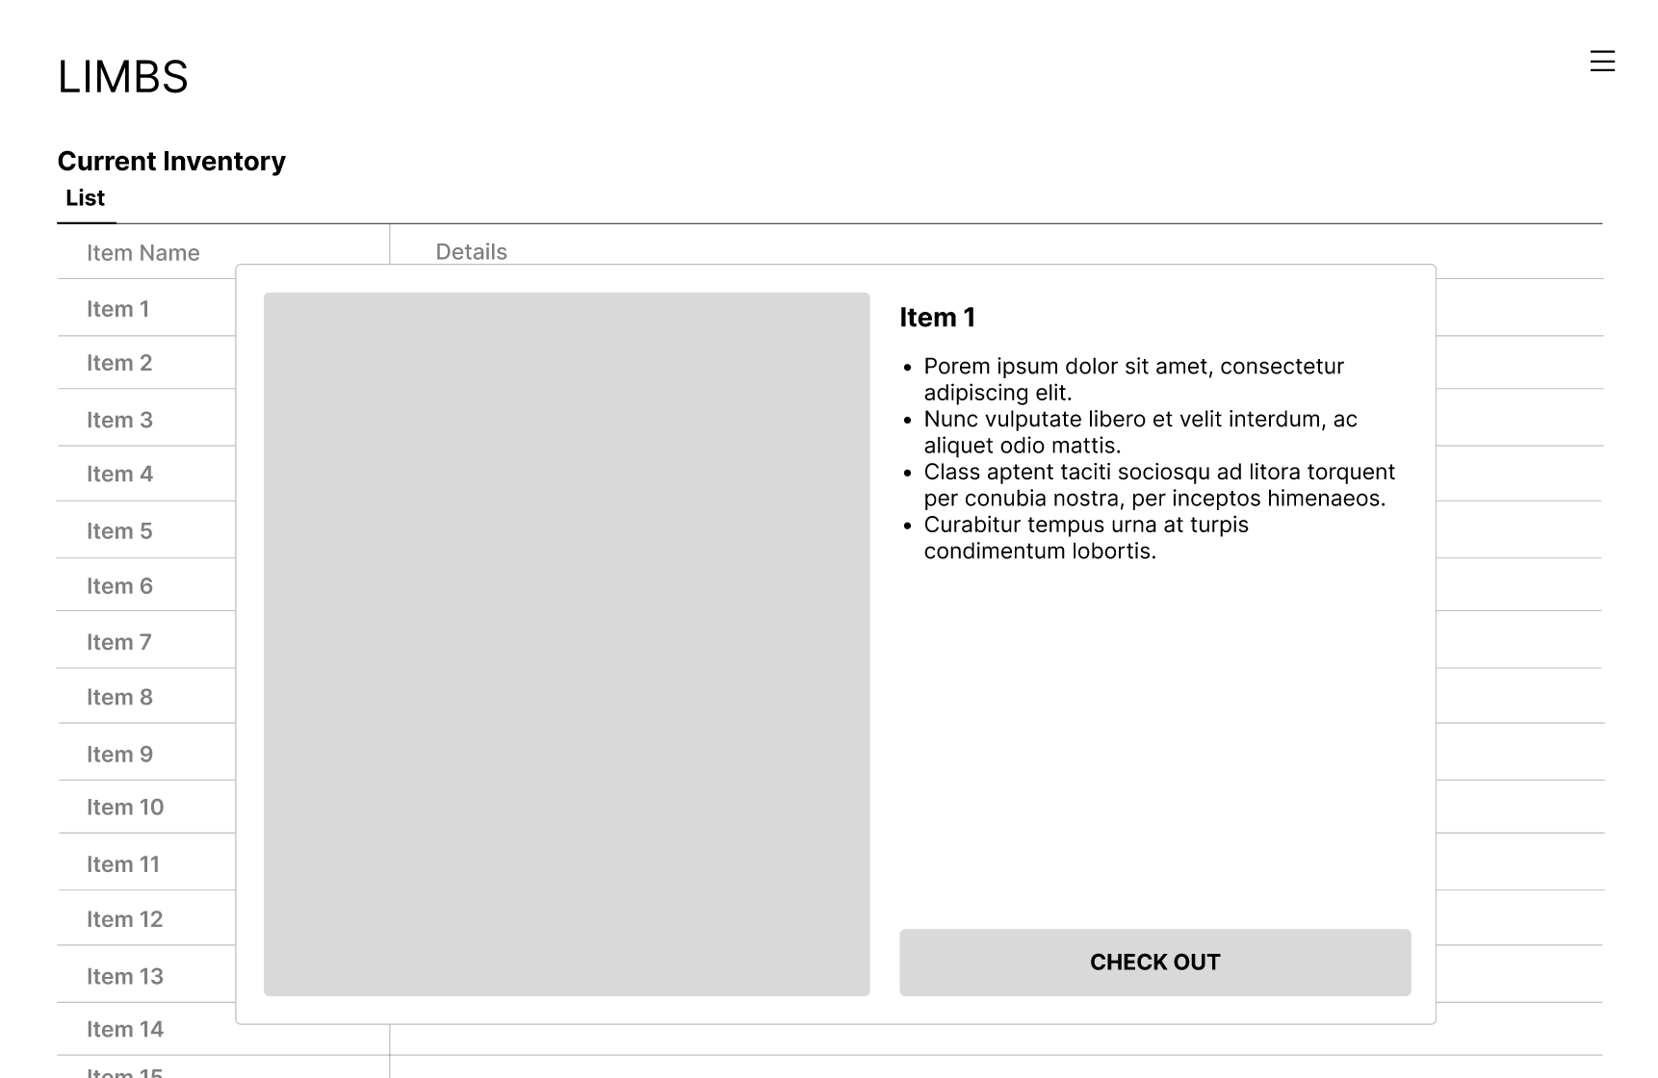

This wireframe is an example of what an administrator might be able to see if they log into LIMBS. The system will give them the ability to edit and select any items to change the status of them, or delete them.

